`LAB Manual

PART A

(PART A : TO BE REFERRED BY STUDENTS)

**Experiment No.03**

**A.1 Aim:**

Identify the project from any of the following application domains as per the current market needs.

* Health Care
* Food industry
* Education
* Business Intelligence etc.

Prepare the business proposal for the selected problem.

**A.2 Prerequisite:**

Understanding of Business proposal and component of Business Proposal.

**A.3 Outcome:**

**After successful completion of this experiment students will be able to:**

Define project proposal by covering following points.

1. Project Sponsor
2. Business Need
3. Business Requirement
4. Business value
5. Special issue or constraints

**A.4 Theory:**

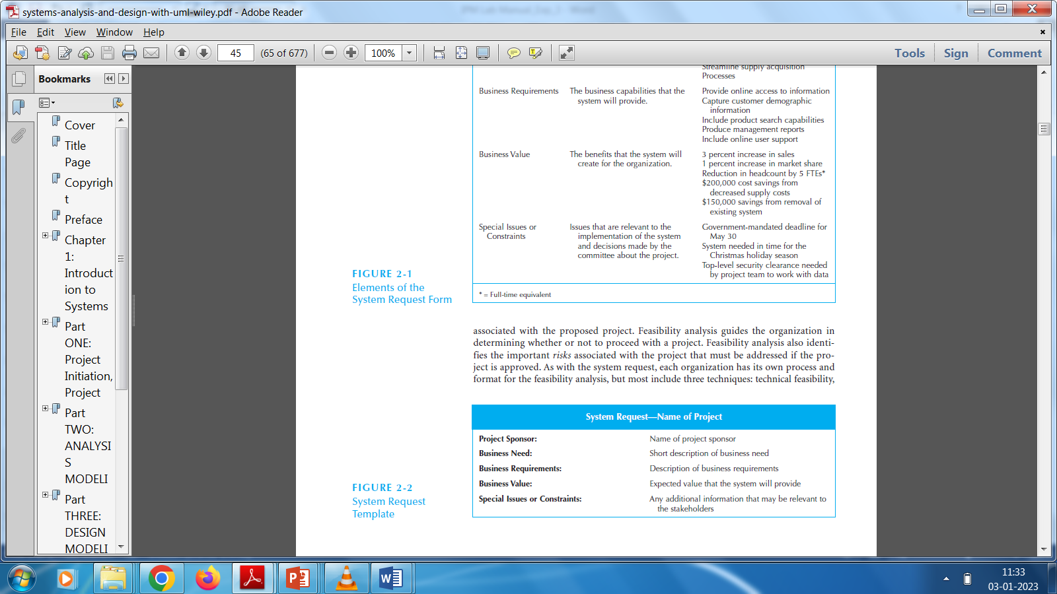

**A.5 Procedure/Algorithm:**

**Sample format of proposal**

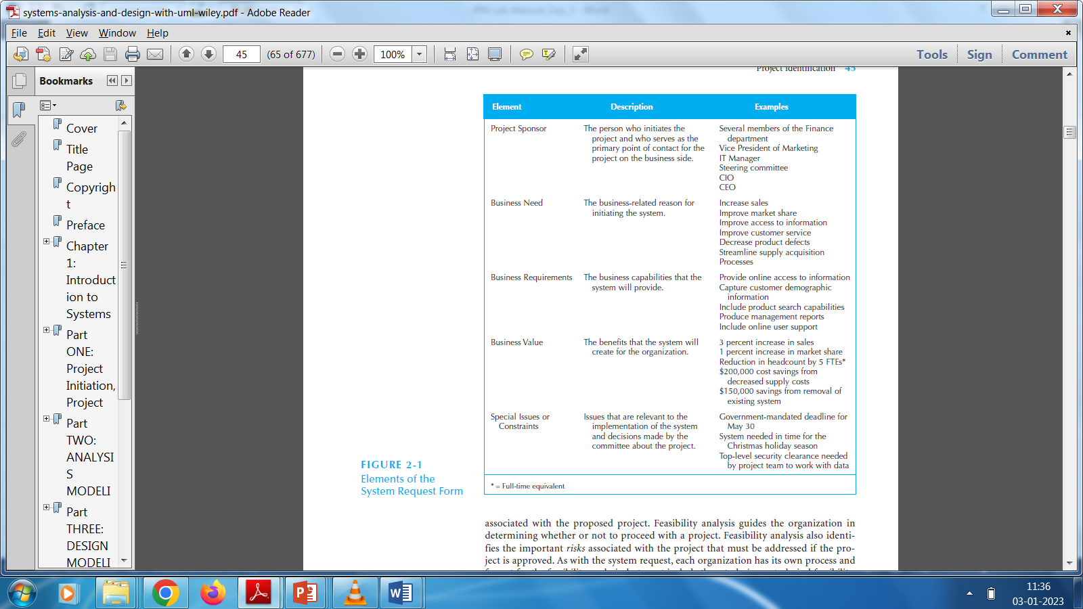

PART B

(PART B : TO BE COMPLETED BY STUDENTS)

***(Students must submit the soft copy as per following segments within two hours of the practical. The soft copy must be uploaded on the Blackboard or emailed to the concerned lab in charge faculties at the end of the practical in case there is no Black board access available)***

| Roll No. | Name: |
| --- | --- |
| Class : | Batch : |
| Date of Experiment: | Date of Submission |
| Grade : |  |

**B.1 Answers of Task to be written by student:**

***(Paste your answers completed during the 2 hours of practical in the lab here)***

**B.2 Observations and learning:**

***(Students are expected to comment on the output obtained with clear observations and learning for each task/ sub part assigned)***

**B.3 Conclusion:**

*(****Students must write the conclusion as per the attainment of individual outcome listed above and learning/observation noted in section B.3)***